- TOTAL REVENUE
SELECT SUM(total_price) as Total_revenue from pizza_sales;
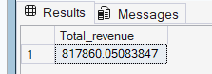
- AVERAGE ORDER VALUE
SELECT sum(total_price) /count(distinct order_id) as Avg_Order_Value from pizza_sales;
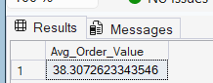
- TOTAL PIZZA SOLD
SELECT sum(quantity) as Total_pizzas_sold from pizza_sales;
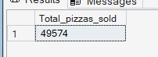

- TOTAL ORDERS
SELECT COUNT(DISTINCT order_id) as Total_orders from pizza_sales;
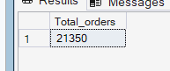
5.AVERAGE PIZZAS PER ORDER
SELECT cast(cast(SUM(quantity) as decimal(10,2))/
cast(COUNT(DISTINCT order_id) as decimal(10,2)) as decimal(10,2)) as Avg_pizzas_Per_order from pizza_sales;
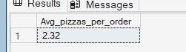

6.Daily trends
SELECT DATENAME(DW, order_date) as order_day, count(distinct order_id) as total_orders from pizza_sales
group by DATENAME(DW, order_date)
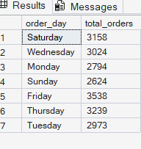
7. monthly trends
SELECT DATENAME(MONTH, order_date) as order_day, count(distinct order_id) as total_orders from pizza_sales
group by DATENAME(MONTH, order_date)
order by total_orders desc

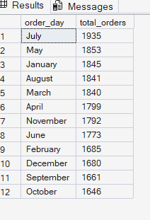
8. percentage of sales by pizza category
SELECT pizza_category,sum(total_price)*100 / (select sum(total_price) from pizza_sales)
from pizza_sales
group by pizza_category;
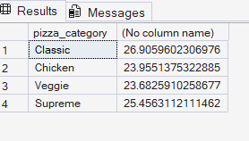

Monthly
SELECT pizza_category,sum(total_price)*100 / (select sum(total_price) from pizza_sales where month(order_date)=1) as percentage_OF_total_sales
from pizza_sales
where month(order_date)=1
group by pizza_category;

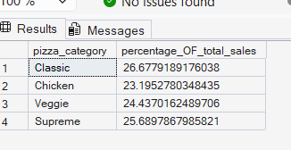
9. percentage of sales by pizza size
SELECT pizza_size,sum(total_price)*100 / (select sum(total_price) from pizza_sales ) as percentage_OF_total_sales
from pizza_sales
group by pizza_size;
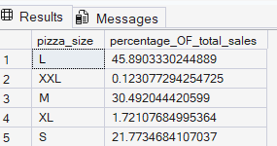

10. percentage of sales by pizza size by quarter

SELECT pizza_size,sum(total_price) as total_sales,sum(total_price)*100 / (select sum(total_price) from pizza_sales where DATEPART(quarter,order_date)=1) as percentage_OF_total_sales
from pizza_sales
where DATEPART(quarter,order_date)=1
group by pizza_size
order by percentage_OF_total_sales desc;
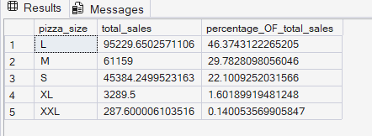

11.TOP 5 pizzas by revenue

select top 5 pizza_name ,sum(total_price) as total_revenue from pizza_sales group by pizza_name order by total_revenue desc ;
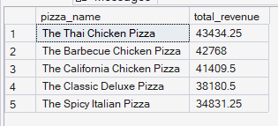
12. BOTTOM 5 PIZZASS BY REVENUE
select top 5 pizza_name ,sum(total_price) as total_revenue from pizza_sales group by pizza_name order by total_revenue asc ;
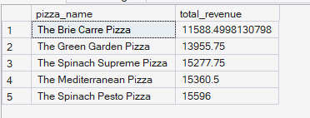
13,TOP 5 BY QUANTITY
select top 5 pizza_name ,SUM(quantity) as total_quantity from pizza_sales group by pizza_name order by total_quantity desc ;
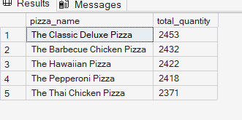
14.BOTTOM 5 BY QUANTITY
select top 5 pizza_name ,SUM(quantity) as total_quantity from pizza_sales group by pizza_name order by total_quantity ASC ;
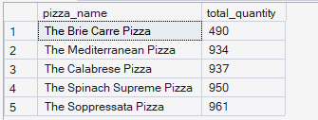

15.top 5 by orders

select top 5 pizza_name ,count(DISTINCT order_id ) as total_orders from pizza_sales group by pizza_name order by total_orders desc; ;

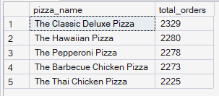

16. bottom 5 by orders
select top 5 pizza_name ,count(DISTINCT order_id ) as total_orders from pizza_sales group by pizza_name order by total_orders asc;
